Cloud Computing Overview (AWS CLI)

HOS09: Amazon Simple Notification Service (SNS)

Developed by Marvin Gold 12/20/2020

Reviewed by Kim Nguyen class of 2021

School of Technology and Computing



**Learning Outcomes**

* Learn about Pub/Sub
* Create an SNS Topic
* Subscribe to an SNS topic
* Publish to an SNS topic
* Unsubscribe from an SNS topic
* Delete a topic

**References**

<https://docs.aws.amazon.com/cli/latest/userguide/cli-services-sns.html>

<https://docs.aws.amazon.com/sns/latest/dg/welcome.html>

https://www.youtube.com/watch?v=M4gQ8MLlgiY

**Step 0:**Watch this short video about AWS SNS <https://www.youtube.com/watch?v=M4gQ8MLlgiY>

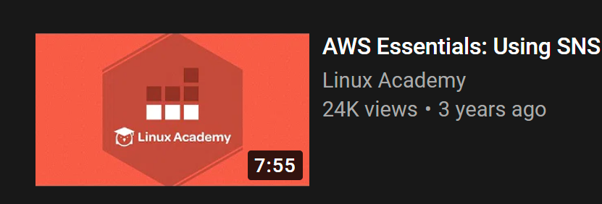

**Step 1: Log onto your Amazon EC2 Instance**

Log onto your Amazon EC2 instance using either OpenSSH, Putty, or from the AWS Management Console using ‘EC2 Instance Connect’ (shown below). Note all IP addresses used in this series of Hands on Skills will be released by the time we start class.

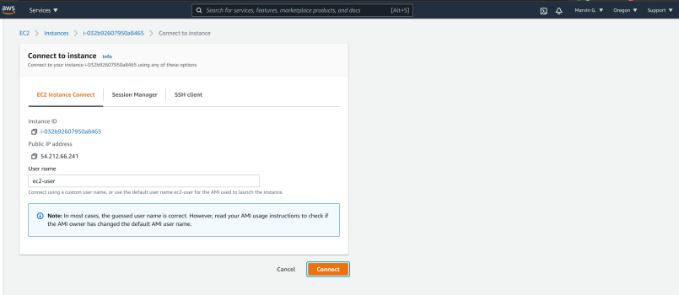

If you receive an error that you must first set your AWS Region and you must configure your AWS CLI, please follow these instructions.

<https://docs.aws.amazon.com/cli/latest/userguide/cli-configure-quickstart.html>  
  
Remember, do not use your root *account* for these operations. You should be using another IAM user. You should not have access keys to your root account.**Step 2: Create a topic**

First we are going to create a topic called “my-first-topic”

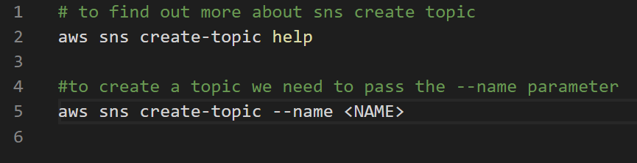

**Attach a SCREENSHOT of your output REDACT YOUR AWS Account ID**

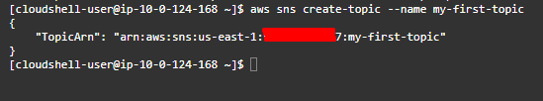

**Step 3: Subscribe to an SNS topic**

Since SNS is a notification system we are going to subscribe an email address to the SNS topic. Email is not the only way you can subscribe. But for the HOS we will use our CityU email.

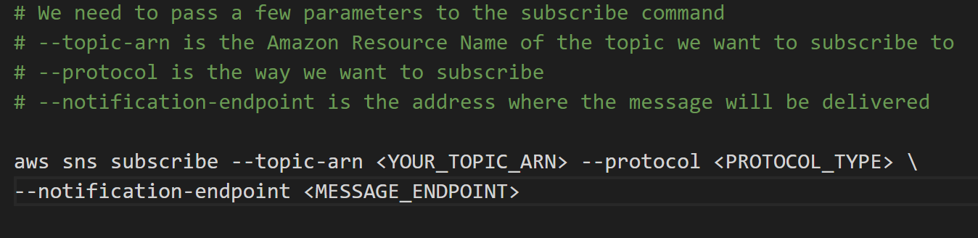

Subscribe your CityU email to your topic. **Attach a SCREENSHOT** of your output

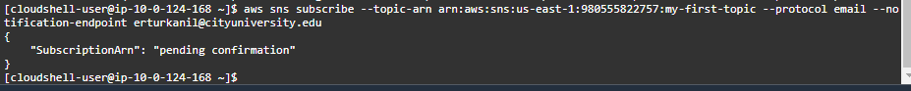

You will receive a confirmation email from AWS, confirm your subscription.

**Step 4: Publish a message to the topic**

When you public a message to a topic, every subscriber gets the message. Let’s publish a message to our topic, we should receive it in our emails.

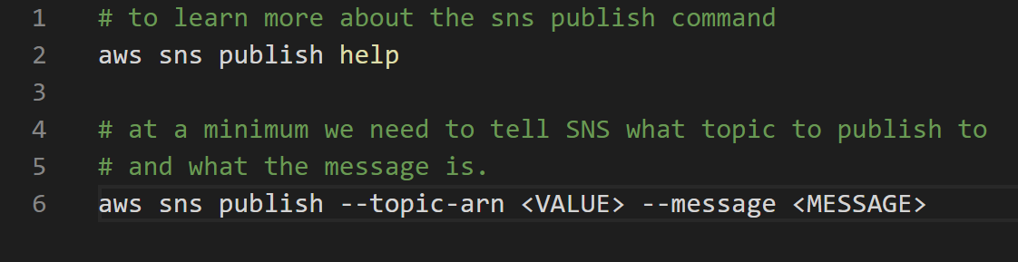

Publish a message of your choosing to your topic , and **ATTACH A SCREENSHOT of the output. REDACT your AWS ACCOUNT ID**

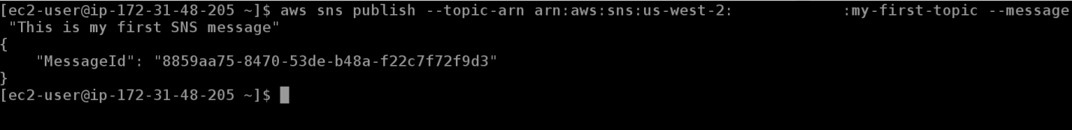



You should receive an email from [no-reply@sns.amazonaws.com](mailto:no-reply@sns.amazonaws.com).

**Step 5: Unsubscribe from a topic, Delete Topic**

To unsubscribe from a topic, we will need the *subscription ARN*. Log into the AWS console, navigate to SNS in the region that we are working out of. Select your topic, and go to subscriptions.

Copy the subscription ARN.

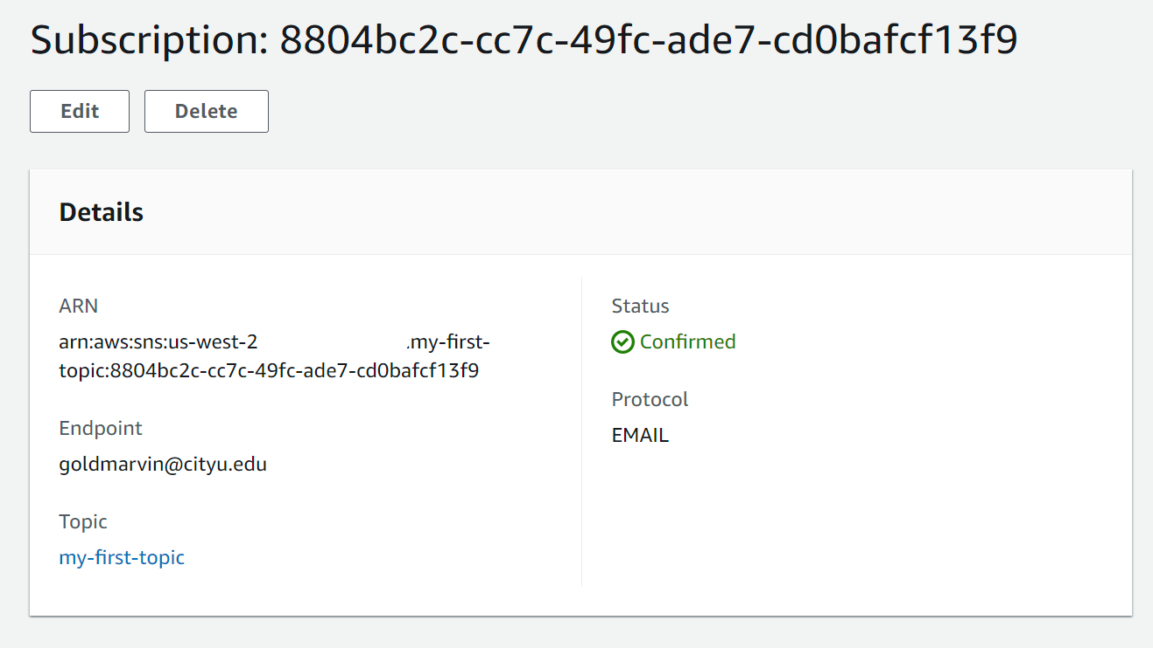

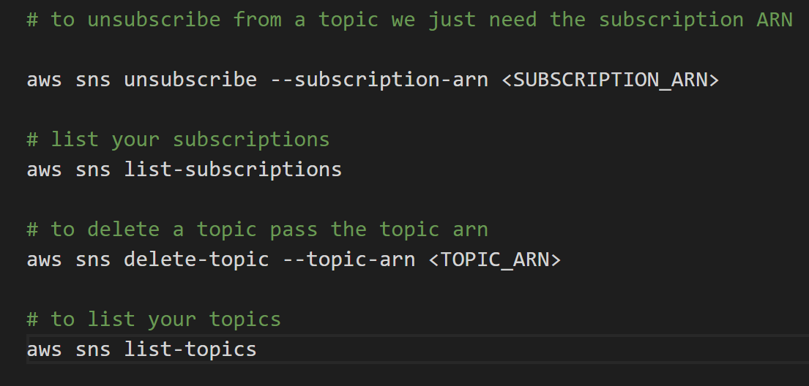

After you unsubscribe from your topic, list your subscriptions to verify. Then delete your topic, and list your topics to verify.